Shaun Fernando Research Plan Cyber School 2020-21

**ACOWA**: **A**pp-driven **C**omponent-based device for **O**ptimizing **W**ater quality data **A**ccuracy

**RATIONALE:**

As the human population rapidly increases, declining water quality has become a global issue. In addition, both citizens and scientists have no convenient or efficient ways of detecting the contents of their water. Most water quality devices are expensive, hard to use, or may not provide accurate data. This issue can occur at a local or at a global level.

**RESEARCH QUESTIONS:**

* Why water quality testing is not a completely unsolved problem?
  + What is the segment of the population this will this technology help?
  + What are the gaps in the current technologies available in the market? *(Gap analysis can be added – see the example at the end of the doc and the solution should fit a white space on the map)*
  + What is the size of the market? *(e.g. XX developing countries with XX population will be able to use this tech)*
* How accurate will the data from the water quality results be?
* Is the app user-friendly that is easy to read and use?

**HYPOTHESIS:**

**Null Hypothesis**: The Engineering Device and app are not accurate and cost effective for their purpose of testing water quality.

**Alternate Hypothesis**: The Engineering Device and app are accurate and cost effective for their purpose of testing water quality.

**GOAL:**

My goal is to engineer a simple, cost effective device to identify accurate traits of acceptable water quality like water temperature and cleanliness.

**EXPECTED OUTCOMES:**

Overall, there should be a significant difference in collected water quality results.

**PROCEDURE:**

ACOWA is designed to be a Component-based platform using Arduino technology to measure water quality readings more accurately. The device is connected to an app which interprets and display data to the user.

The Arduino component comprises of a variety of sensors to identify multiple points of testing, such as pH levels, temperature, and total dissolved solid levels. In addition, a GPS sensor is used to track the locations of the test sites. (Component based tier to Collect Data, Store and Transmit)

The device is integrated with a free, user-friendly, cloud-based app, available on the App store to render collected water quality results. (The Presentation Tier)

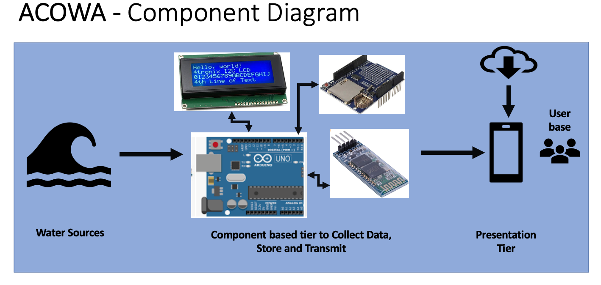

**RISK AND SAFETY:**

**NA**

**BIBILIOGRAPHY:**

Water Science Journal

<https://www.tandfonline.com/action/journalInformation?show=aimsScope&journalCode=twas20&gclid=CjwKCAiA57D_BRAZEiwAZcfCxSkOUdM0bIzVzMkQlptqRZmlsSWokx8UbJ03xBkSI68f6aks5rZJ3xoC1DEQAvD_BwE&>

Sustainability of Water Quality and Ecology Journal

<https://www.journals.elsevier.com/sustainability-of-water-quality-and-ecology>

Issue on Water Quality Control and Management

<https://www.mdpi.com/journal/water/special_issues/water-quality>

Journal of Civil and Environmental Engineering

<https://www.hilarispublisher.com/scholarly/water-quality-journals-articles-ppts-list-1815.htm>

21 Percent of Americans “Very Worried” About Drinking Water Quality

<https://accountablescience.com/poll-21-percent-of-americans-very-worried-about-drinking-water-quality/?utm_source=Google&utm_medium=cpc&gclid=Cj0KCQiA0MD_BRCTARIsADXoopZUpUvgFJxE1ZFoAeJVwPQbUUEEaNUSTeNO69FDGHCqGQLg5Y8-LtkaAuxBEALw_wcB>

Thirst Project

https://www.thirstproject.org/water-crisis/?gclid=Cj0KCQiA0MD_BRCTARIsADXoopaAHhFUAkBtiCkCQip-bRPQyvTd-Gah0tSUUHDN1rJNcaY4_mLDWywaAtdDEALw_wcB

